**Name:-** Gaurang Raorane **Div:-** D15A

**Roll No:-** 49 **Batch:-** C

**EXPERIMENT 12**

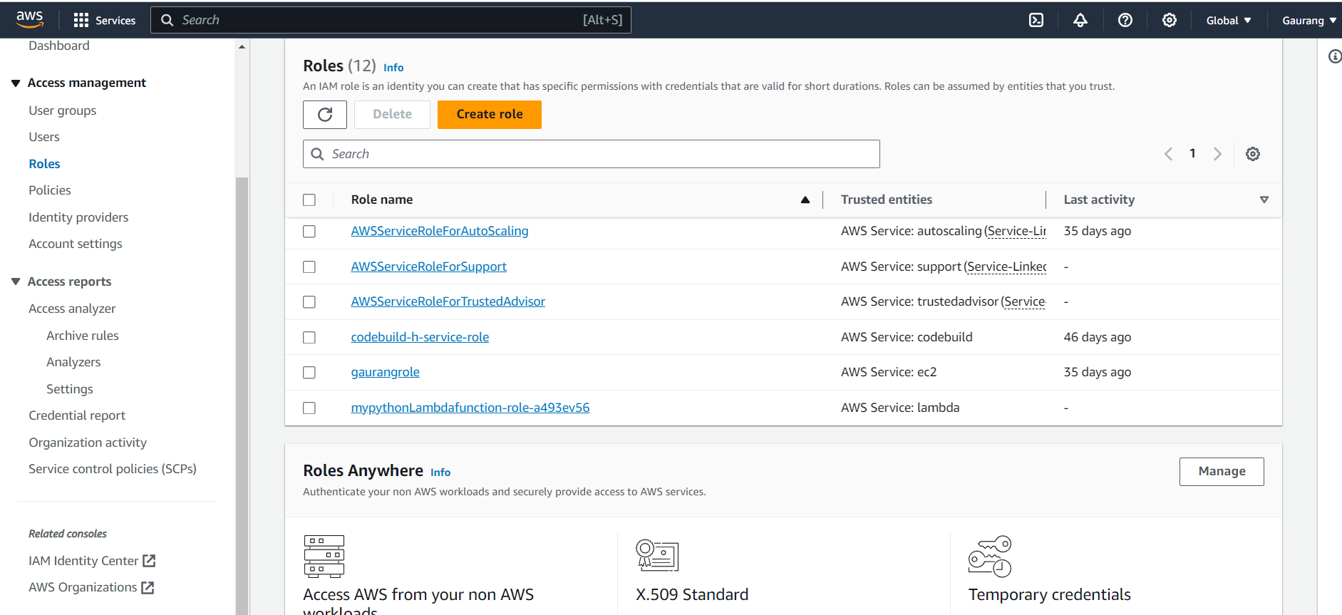

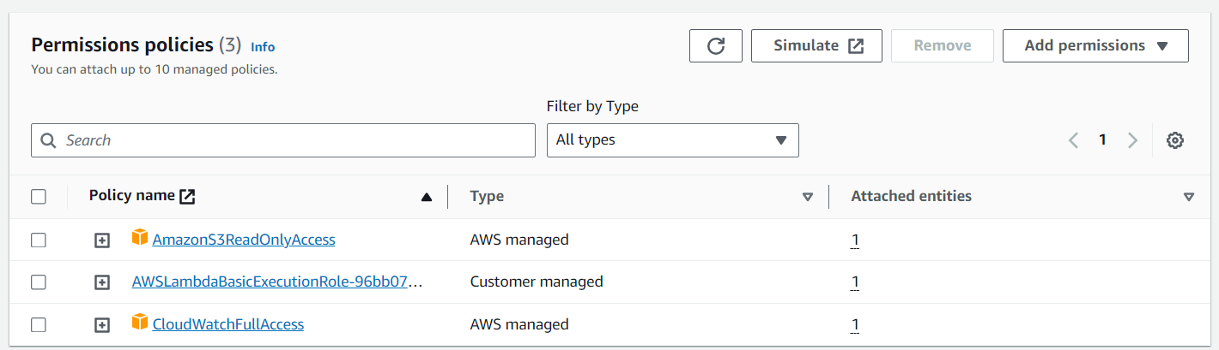

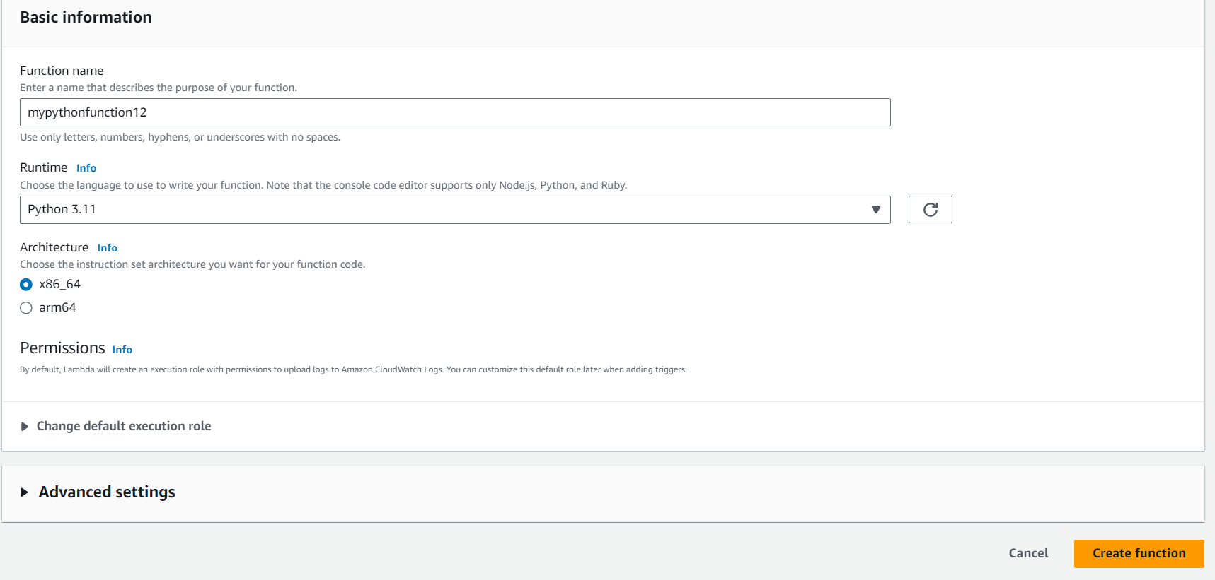

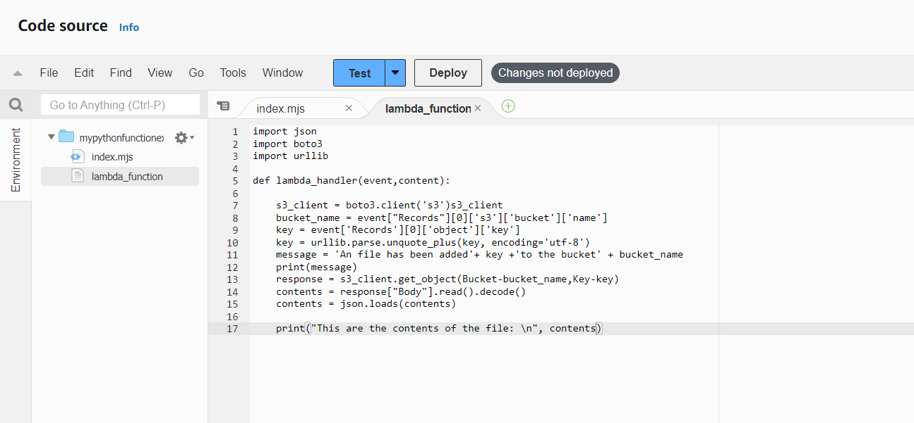

import json

import boto3

import urllib

def lambda_handler(event,content):

s3_client = boto3.client('s3')s3_client

bucket_name = event["Records"][0]['s3']['bucket']['name']

key = event['Records'][0]['object']['key']

key = urllib.parse.unquote_plus(key, encoding='utf-8')

message = 'An file has been added'+ key +'to the bucket' + bucket_name

print(message)

response = s3_client.get_object(Bucket-bucket_name,Key-key)

contents = response["Body"].read().decode()

contents = json.loads(contents)

print("This are the contents of the file: \n", contents)

